Дополнительные материалы к теме «Природа»
(6 класс)
Коммуникативная задача:
- Объяснить необходимость защиты растений.
Материалы подготовлены учителем английского языка квалификационной категории «учитель-методист» государственного учреждения образования «Средняя школа №6 г. Жодино» Коледа С.М.

WE ARE ABOUT TO DISAPPEAR

- Match the pictures and the names of the plants.
- European pine B. Lady's slipper C. Dwarf birch D. Royal fern

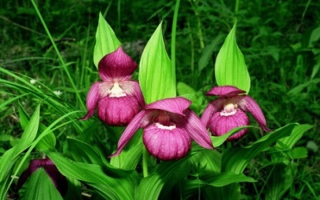 | 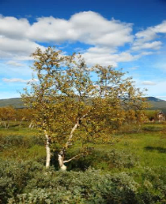 | 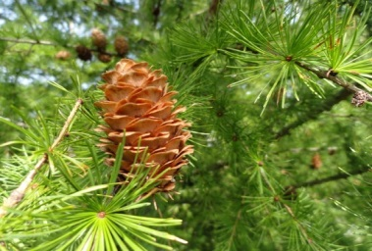 | 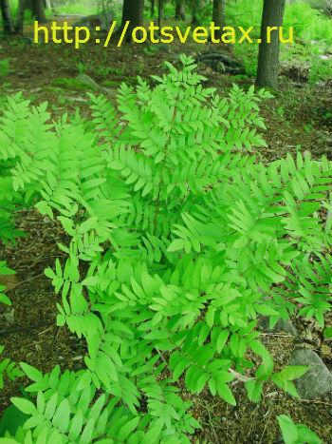
1. | 2. | 3. | 4.

- Define the meaning of the following words.

1. | To overgraze | A | (of trees, plants) having green leaves throughout the entire year
2. | To inhabit | B | a person or thing that is able to resist surviving something
3. | A ravine | C | to graze to excess
4. | A pasture | D | a narrow steep-sided valley commonly eroded by running water
5. | Evergreen | E | to live or dwell in (a place), as people or animals
6. | Resistant | F | an area covered with grass or other plants used or suitable for grazing

- Read the texts and underline the reasons for plants’ disappearance.

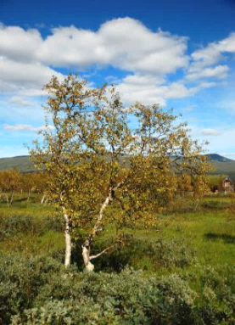
- Dwarf birches usually grow in areas with wet and cold climate. The most inhabited parts in Belarus are swamps. Trees have small, roundish leaves with greenish to brownish flowers. The trunks of birches are covered with white or darkish, often papery bark. The trees are not very high – 0.2-0.8 metres. They are overgrazed mostly by wild deer and elk. They are becoming extinct because of deforestation and disappearance of swamps. They easily burn even when fresh.
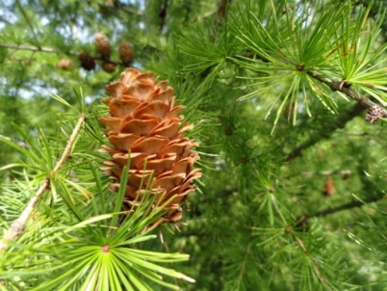
- European pine is a large evergreen tree growing to 20-55 metres tall. The bark is grey to yellow brown. The leaves (needles) are thin and flexible. Trees grow very fast at about 30-70 centimetres per year. The tree can be long-lived, with some trees over 500 years old. It needs good sun to grow well, it is intolerant to shade but it is resistant to snow and low temperatures.

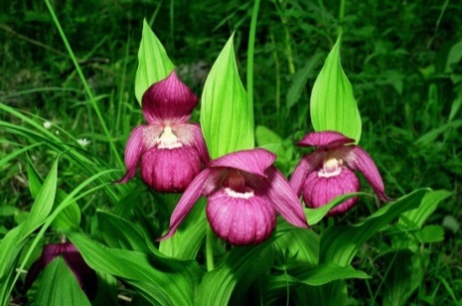
- Lady's slipper (венерин башмачок) has a widespread distribution from Spain to the Pacific, including almost every country in Europe plus Belarus. It is typically found in open woodland on moist soils. In continental Europe it is also found growing in the decomposed humus of semi-shaded woodland. It is resistant to full sun but prefers partial shade for some part of the day. It flowers in early to midsummer, usually with 1 to 2 flowers per stalk, less commonly 3 or 4. Despite producing a large amount of seeds per seed pod, its reproduction largely depends on insects. This rare plant is listed in the Red Book of Belarus and is about to vanish from much of its historical range due to the habitat loss.
- Royal fern (королевский папоротник) usually grows in woodland bogs and on the banks of streams, in damp ravines, on pastures and meadows. It is difficult to define the homeland of a plant as the royal fern grows worldwide. The royal fern is the representative of the most primitive group of ferns. Many representatives of family have large leaves of very big sizes, so, for example, leaves of a royal fern can reach from sixty centimeters to two meters. The leaves are green but in autumn they turn yellow. Growing quite slowly, the royal fern prefers shady and slightly shaded place. According to Slavic mythology the royal fern has magical powers, such as fulfill wishes, unlock secrets, and help understand the language of trees.

- Discuss with your partner: Should the plants be protected? Why? Report to the group.

Дополнительные материалы к теме «Природа»
(6 класс)
Коммуникативная задача:
- Описать растения, нуждающиеся в защите.
Материалы подготовлены учителем английского языка квалификационной категории «учитель-методист» государственного учреждения образования «Средняя школа №6 г. Жодино» Коледа С.М.

OUR UNIQUE NATURE

- Do you know the names of these flowers? Match the pictures and the names of flowers.
A | B | C | D | E | F
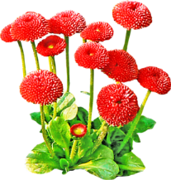 | 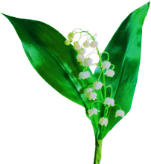 | 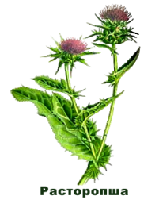 | 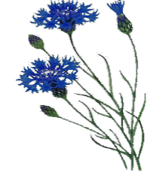 | 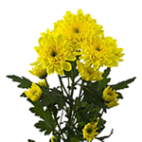 | 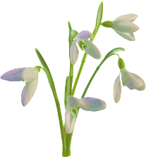

1. | snowdrop | 2. | cornflower | 3. | daisy
4. | lily of the valley | 5. | thistle | 6. | chrysanthemum
- Read the texts with your partner to learn more about different flowers. Which legend do you like most? Why? Report to the group.
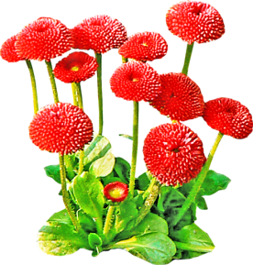
In England daisies are associated with the coming of spring. There is an old English saying that spring does not come until you can set your foot on twelve daisies.
Daisies can grow practically everywhere. They appear early in spring. Daisies’ petals open at dawn and close at dusk. They are often of different colours and smell fantastic. In England daisies are called flowers of innocence.
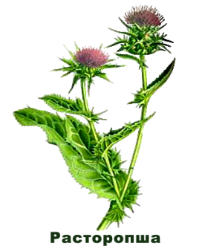
In the language of flowers, the thistle is an ancient Celtic symbol of nobility of character as well as of birth, for the wounding or provocation of a thistle yields punishment. For this reason the thistle is the symbol of the Order of the Thistle, a high chivalric order of Scotland.
A well-known myth says that a bare footed Viking attacker stepped on a thistle at night and cried out, so alerting the defenders of a Scottish castle. The thistle is the national flower of Scotland since the 15th century.
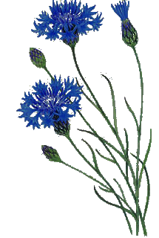
A cornflower is a small annual flowering plant native to Europe. In England a cornflower means «a flower growing in the fields together with corn - grains such as wheat, barley, rye, or oats which are formerly known as corn fields».
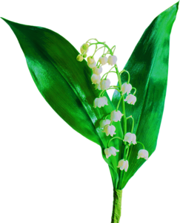
In folklore, cornflowers were worn by young men in love; if the flower faded too quickly, it was taken as a sign that the man's love was not returned.
The lily of the valley’s scientific name «Majalis» means «that which belongs to May». It signifies the return of happiness. Legends tell of the affection of the lily of the valley for a nightingale that did not come back to the woods until the flower bloomed in May.

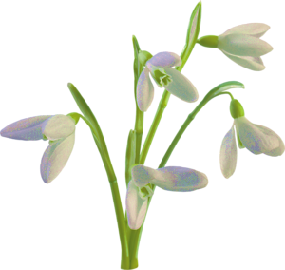
One of the legends about the origin of the snowdrop tells us that after being expelled from the Garden of Eden, Eve was sitting weeping. An angel was trying to comfort her. Since autumn, no flowers had bloomed, but snow fell ceaselessly. Talking to Eve the angel caught a snowflake in his hand, breathed on it, and it fell to the ground as the first snowdrop. The flower bloomed and Hope was born.
In Germany there is a different snowdrop legend. When God made all things on the Earth, he asked the snow to go to the flowers and get a little colour from them. One by one the flowers refused. Then, very sad, the snow asked a snowdrop to give him a little of its colour and the snowdrop accepted. As a reward, the snow let it bloom first whenever spring comes.
The name chrysanthemum was first heard in England in the late 1500's. Englishmen had been calling the flower corn marigold but when they began importing flowers from the Far East, the name changed to that of the Oriental species which was called chrysanthemum.
Chrysanthemums were the favorites of the Nobility in China, and common people were not allowed to grow them. The Asians consider it to be a sacred flower but the world's greatest chrysanthemum growers are the Japanese, who first got the flower from China at the end of the 4th c. A.D.

- Find in the text answers to the following questions:
- What flowers are associated with the coming of spring?
- What does a cornflower mean?
- What flower is the national flower of Scotland?
- Daisies and chrysanthemums are often of different colours, aren’t they?
- People of what nationality are the world's greatest chrysanthemum growers?
- Discuss with your partner: Were any of these flowers included in the Red book? Which ones?
- Work in groups. Write down your own legend about a flower.
Дополнительные материалы к теме «Природа»
(6 класс)
Коммуникативная задача:
- Сравнить животный и растительный мир Республики Беларусь и страны изучаемого языка

Материалы подготовлены учителем английского языка квалификационной категории «учитель-методист» государственного учреждения образования «Средняя школа №6 г. Жодино» Коледа С.М.

FLORA AND FAUNA OF THE UNITED KINGDOM OF GREAT BRITAIN AND NORTHERN IRELAND

- Read about the flora and fauna in Britain. Use the pictures for help.
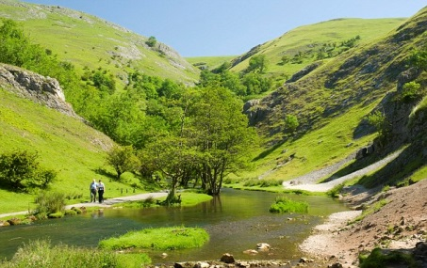
Over the centuries, much of the forest area, especially on the lowlands, was cleared for cultivation; it means that today only about 9% of the total surface is wooded. Fairly extensive forests remain in east and north Scotland and in southeast England.
Among the most widely spread trees in England are oak, elm, ash and beech. What concerns Scotland pine and birch trees are most common there.
Almost all the lowland outside the industrial centres is farmland, with a varied semi natural vegetation of grasses and flowering plants. Wild vegetation consists of the natural flora of woods, fens and marshes, cliffs, chalk downs, and mountain slopes, the most widespread being the heather, grasses, gorse, and bracken of the moorlands.

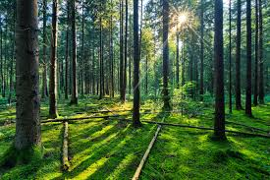 | 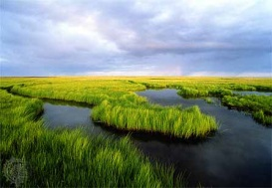 | 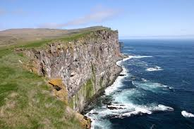 | 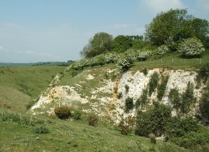 | 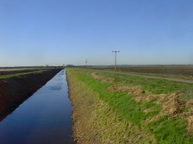
woods | marshes | cliffs | chalk downs | fens

The fauna of the United Kingdom of Great Britain and Northern Ireland is similar to that of northwestern continental Europe, although there are fewer species. Some of the larger mammals – wolf, bear, boar, and reindeer – are extinct, but red and roe deer are protected for sport. Common smaller mammals are foxes, hares, hedgehogs, rabbits, weasels, stoats, shrews, rats, and mice; otters are found in many rivers, and seals frequently appear along the coast.

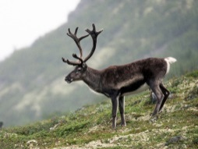 | 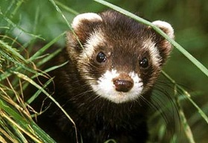 | 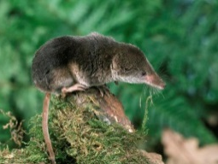 | 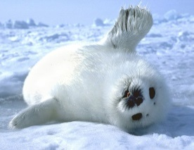 | 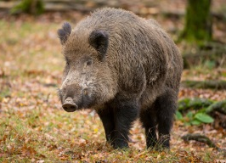
reindeer | weasel | shrew | seal | boar

There are few reptiles and amphibians. 230 species of birds reside in the United Kingdom and another 200 are migratory. Most numerous are the chaffinch, blackbird, sparrow, and starling. Robin Redbreast is the national bird of Britain. The number of large birds is declining, however, except for game birds – pheasant, partridge, and red grouse – which are protected.

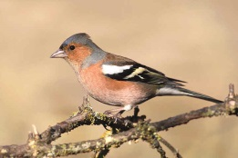 | 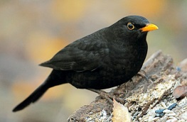 | 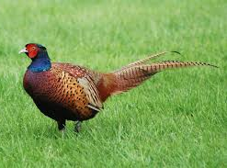 | 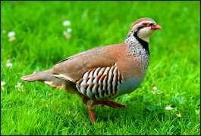 | 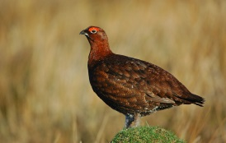
chaffinch | blackbird | pheasant | partridge | red grouse

The rivers and lakes are full of salmon, trout, perch, pike, roach, dace, and grayling.

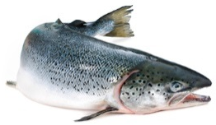 | 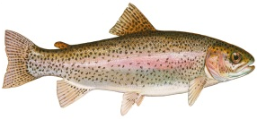 | 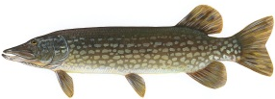 | 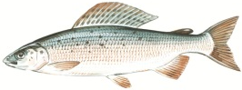 | 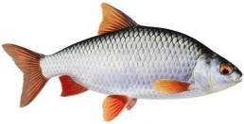
salmon | trout | pike | grayling | roach

There are more than 21,000 species of insects.
What a pity there are many threats to wildlife and ecological balance around the coast. The biggest threat to the coastline is pollution. More than 3.500 million tons of industrial waste is pumped into the North Sea every year. «We cannot continue to use our seas as a dustbin and expect our coastline to survive», says Greenpeace.

- Work in pairs. Ask and answer the questions.
- Are there many forests in the United Kingdom of Great Britain and Northern Ireland?
- What are the most widely spread trees in England/ Scotland?
- What mammals can you see there?
- What species of birds and fish inhabit Britain?
- What bird is the national bird of Britain?
- What is the biggest threat to wildlife in Britain?

FLORA AND FAUNA OF THE REPUBLIC OF BELARUS

- Read about the flora and fauna in Belarus. Use the pictures for help.

Belarusian flora is represented by forests, meadows, swamps, aquatic vegetation and shrubs. There are more than 100 types of trees and shrubs in Belarus. Forests cover 39.8% of the country’s territory. Among the most widely spread trees in Belarus are pine, spruce, oak, hornbeam, maple, ash, linden, birch, aspen, willow and alder.

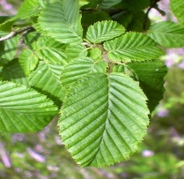 | 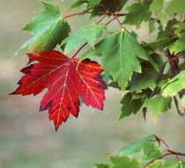 | 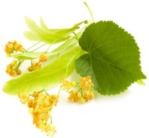 | 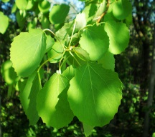 | 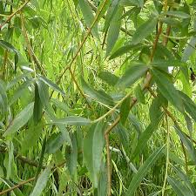 | 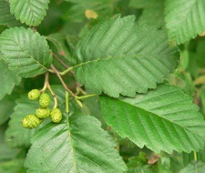
hornbeam | maple | linden | aspen | willow | alder

Swamps occupy 1.7 million hectares of Belarus. The most often spread swamp vegetation is sedge, mosses, cranberry, rush, calamus and pike rush.
There are 76 species of animals in Belarus. Among them are elk, roe, hare, squirrel, bear, wild boar, marten, fox, wolf, weasel, badger, lynx, ermine, hedgehog, mole, common shrew, rodents, beaver, beaver-rat, mink and otter.

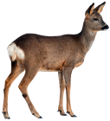 | 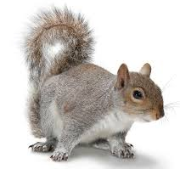 | 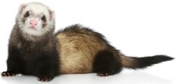 | 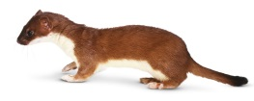 | 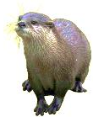
roe | squirrel | marten | weasel | otter

309 species of birds inhabit the territory of the country: black woodpecker, titmouse, bullfinch, crane, black and white storks, hazel grouse, black-cock, thrush, cuckoo, hawk and vulture are among them. White stork is the symbol of the country.

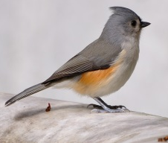 | 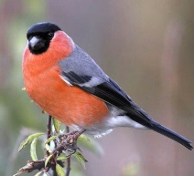 | 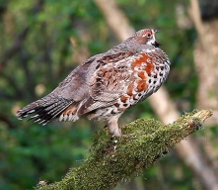 | 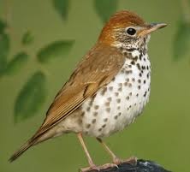 | 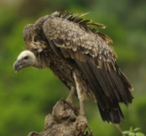 | 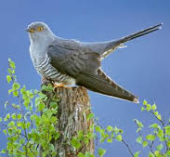
titmouse | bullfinch | hazel grouse | thrush | vulture | cuckoo

In Belarus one can see 7 species of reptiles, including one species of turtles, three species of snakes and three species of lizards. There are 58 species of fish in Belarusian rivers: dace, tench, crucian carp, pike, bream, orfe, catfish, perch and eel.
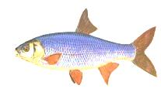 | 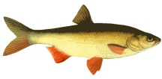 | 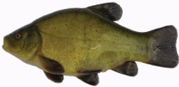 | 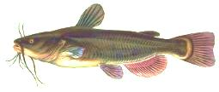 | 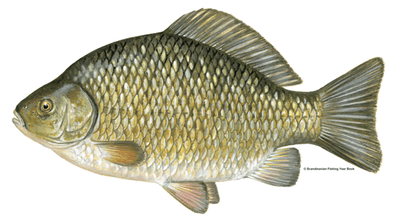 | 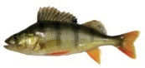
dace | orfe | tench | catfish | crucian carp | perch

- Work in pairs. Ask and answer the questions.
- What is Belarusian flora represented by?
- How many types of trees are there in Belarus?
- What territory is covered by forests in Belarus?
- What are the most widely spread types of trees/ species of animals and birds in Belarus?
- Do any reptiles inhabit the territory of Belarus?

- Work with your partner: Do Belarusian and British fauna and flora have much in common? Why? Why not? Report to the group.

- Fill in the table. Speak to your classmates about Belarusian and British flora and fauna.

The United Kingdom of Great Britain and Northern Ireland |  |  |  | Belarus
Trees | Fish | Animals | Birds | Trees | Fish | Animals | Birds
pine | trout | deer | pheasant | aspen | dace | bear | thrush

Work with your partner. Find 8 species of plants, 5 species of animals and 7 species of birds.
W | A | B | D | E | F | C | B | Y | B | E | A | R | E | R
O | M | G | F | D | T | H | I | S | T | L | E | R | T | O
L | N | Q | W | F | D | R | O | S | E | L | H | Y | J | A
F | O | X | D | V | G | Y | F | T | R | O | U | T | H | C
Q | W | E | R | V | T | S | N | O | W | D | R | O | P | H
Y | U | I | O | C | D | A | I | S | Y | P | A | S | I | D
F | G | H | C | O | R | N | F | L | O | W | E | R | K | J
L | I | L | Y | O | F | T | H | E | V | A | L | L | E | Y
M | P | N | B | V | C | H | X | C | A | T | F | I | S | H
K | E | L | P | I | N | E | U | Y | H | A | R | E | P | O
E | R | C | V | B | N | M | M | S | A | L | M | O | N | U
N | C | H | B | N | C | U | C | K | O | O | P | E | R | T
M | H | F | V | V | N | M | V | B | D | A | C | E | H | J

ANSWERS
W |  |  |  |  |  | C |  |  | B | E | A | R |  | R
O |  |  |  |  | T | H | I | S | T | L | E |  |  | O
L |  |  |  |  |  | R | O | S | E |  |  |  |  | A
F | O | X |  |  |  | Y |  | T | R | O | U | T |  | C
 |  |  |  |  |  | S | N | O | W | D | R | O | P | H
 |  |  |  |  | D | A | I | S | Y |  |  |  | I
 |  |  | C | O | R | N | F | L | O | W | E | R | K
L | I | L | Y | O | F | T | H | E | V | A | L | L | E | Y
 | P |  |  |  |  | H |  | C | A | T | F | I | S | H
 | E |  | P | I | N | E |  |  | H | A | R | E
 | R |  |  |  |  | M |  | S | A | L | M | O | N
 | C |  |  |  | C | U | C | K | O | O
 | H |  |  |  |  | M |  |  | D | A | C | E

